Troubleshooting

Errorlogs –

SQL, Windows Event logs

Wait stats –

Dmo.waitstat

Sos_shheduler_yield – cpu pressure

Cxpacket – parallelism

Locking

Lck_X, lck_m_u, lck_m_x

Memory

Pagelatch_x, latch_x

Memory grants resource_semaphore

I\O

Bufferi\o latch pageiolatch_x

Network pressure

Network i\o async_network_io

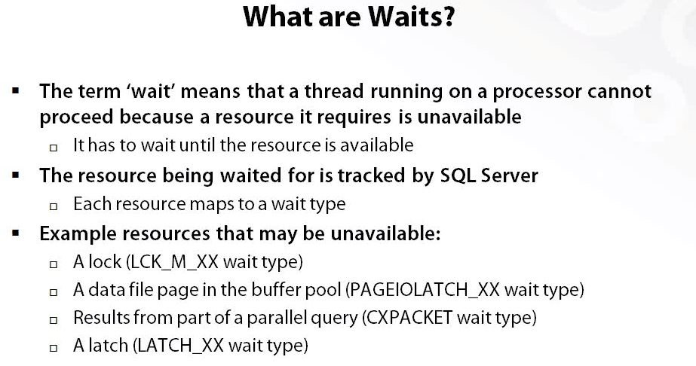

Perfmon –

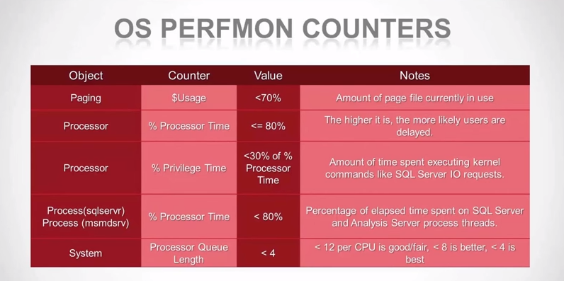

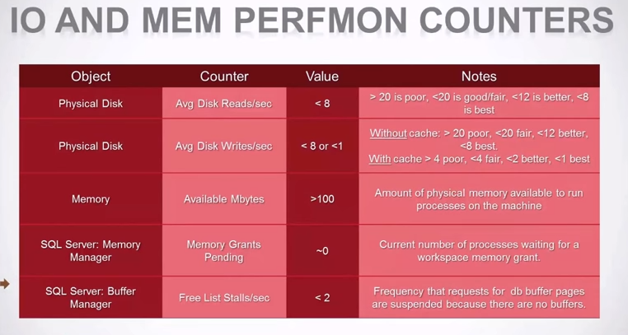

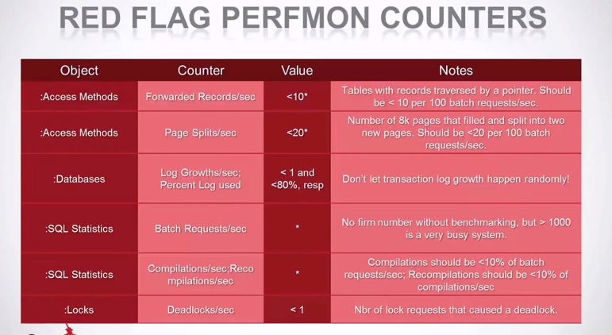

Profiler / Xevents –

Performance

Sys.dm_os_wait_stats -- waits that have occurred since last cycle or cleared

Sys.dm_os_performatnce_counters

Sys.dm_os_waiting_tasks -- whats happening now

i\o

sys.dm_io_virtual_file_stats

sys.dm_io_pending_io_requests

Transactions

Sys.dm_tran_lock

Sys.dm_db_index_operational_stats

Sys.dm_db_index_usage_stats

Spid activity & SQL statements

Sys.dm_os_exec_requests

Sys.dm_exec_requests

Sys.dm_exec_query_stats

Sys.dm_{procedure | trigger}_stats

Sys.dm_os_schedulers

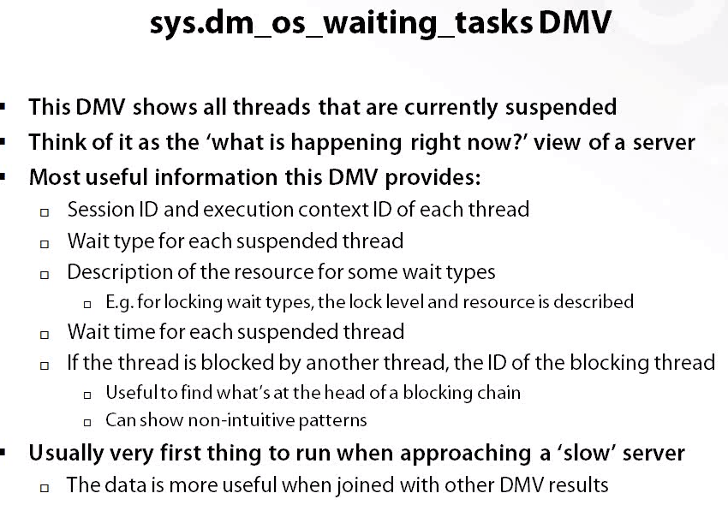

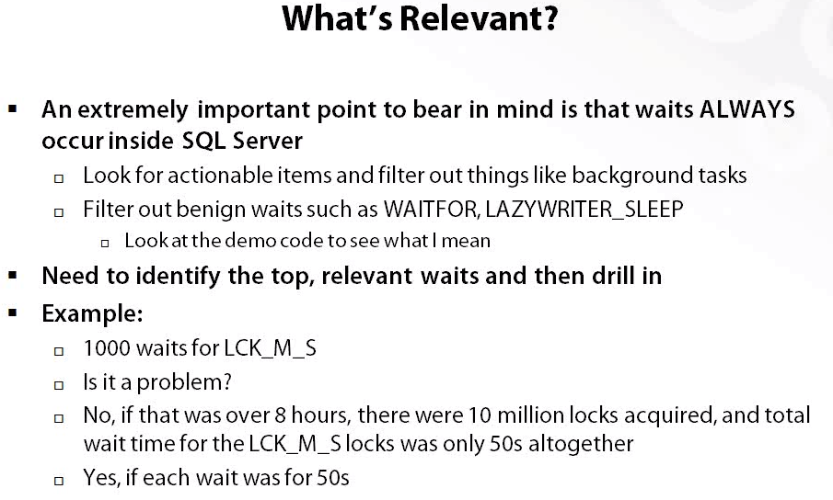



<http://sqlsentry.tv>

